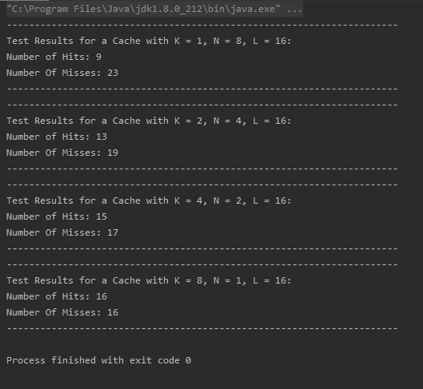

Console output from running my t6 solution. Tests are ran from the mainline using the testInstructions function and supplying caches with different specifications.